CENG 5333

Dr. Pete Rogers

**Final Project Report**

Matt Alexander

3 May 2010

Measuring Reservoir Reliability Using Extended Drought Records

# Introduction

This paper is an investigation of a method to analyze historical drought reconstructions for the goal of giving water supply managers a better idea of how to anticipate future drought events. Drought is a difficult thing to define and describe quantitatively. Flooding, because of the generally short durations of flood events, are easier to measure. Droughts are a longer “creeping disaster” that people often don’t realize the magnitude of until the lack of water is evident in the death of crops, trees, and dramatic water level declines in their recreational and water supply reservoirs. In a time when people of the world are increasingly aware about climate shifts and future drought cause by “climate change”, an important first practical step in understanding the problem could be to analyze current water supplies with respect to what we know about historic drought conditions and variability. This investigation is in two parts: first, historical drought will be described mathematically and historic drought events will be assigned a recurrence interval; second, the drought index reconstruction will be used to simulate reservoir inflows, evaporation and precipitation for years before those data were recorded. Reservoir models will be run to determine the firm yield of a particular reservoir during the period of record and then with the extended data, to compare between the data, and to see if extending the period of simulation could improve current models and estimates of firm yield.

# Background

The design of reservoirs in Texas is done by using the longest precipitation, evaporation and inflow data available. Reservoir models are then run using these data to determine what the firm yield of the reservoir is so that water rights can be allocated. Tree rings have been studied for nearly 100 years as indicators of drought. In the past 20 years, researchers have been using the tree ring data to correlate with other climate indices. One of these approaches has used the Palmer Drought Index (PDI). The PDI is essentially “reconstructed” for the years where tree ring information exists, but measured climate data do not. In the Dallas region, there are several reconstructions that may prove useful to water supply managers, since the available tree ring data and thus the drought reconstructions go back all the way to the year 998. This paper’s intent is to use the correlated tree ring/PDI data made available by Cook (Cook, et al., 1999) with available precipitation and evaporation data (called net evaporation) and historical stream flows, to run standard reservoir models and determine the reservoir’s firm yield.

# Model Formulation

Drought is a function of two variables: duration and severity. Figure 1 is a schematic that shows this relationship. Droughts are extreme events, and both variables can be described by a probability distribution. These distributions are combined in a formulation that describes the frequency of drought events. Modeling this data involves 2 steps:

1. Describing the Severity, and the Duration components of drought individually, with probability distributions (henceforth, *marginal* distributions)
2. Combining the two marginal distributions into a single bivariate distribution that accounts for the dependence of the two variables on each other.

Figure 1. Schematic for Duration (d), Severity (s), and Interarrival Time (t).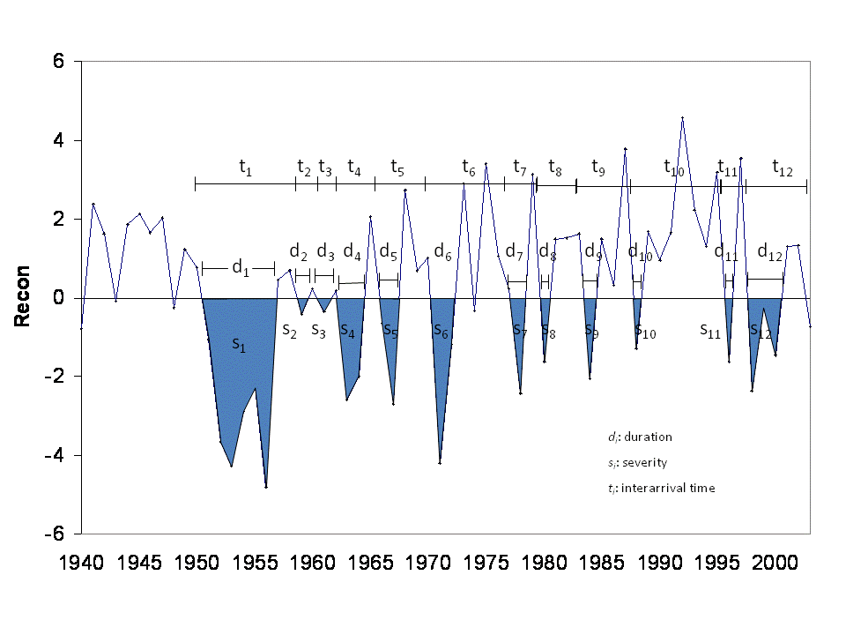

The data for the drought reconstruction comes from Cook et al., 1999, and is shown in Figure 2. The reconstruction is combined with actual measured data for the period of record, which is shown in Figure 3, and clearly shows what water suppliers have called the “drought of record” from 1951 – 1957.

Figure 2. Parmer Drought Index ReconstructionFigure 3. Palmer Drought Index (Period of Record)

# Solution Approach

In order to actually pull a list of droughts with their severity and duration information from the 1000 year record, a small piece of code was needed. This code is described in Appendix A. The code parses the reconstruction for years where the PDI was less than 0, and if a year or more were less than 0, it consolidated the years into a single “drought event.” The code returned 195 drought events with durations 1 year or greater, with their corresponding durations, severities, and interarrival times (tn in Figure 1).

## Univariate Descriptions (Marginal Distributions for Severity and Duration)

Once the drought record was established the droughts were analyzed using gamma distributions and fitted gamma distributions were developed using the method of least squares. The cumulative distribution functions for the drought’s duration and severity are shown below in Figures 4 and 5.

The gamma distribution (cdf):



P is the probability that a single from the gamma distribution (with parameters a and b) fall in the interval [0,x] (Mathworks, 2010).

Since both duration and severity use the same distribution, only the parameters change for each:

Table 1. Parameters Used for Respective Marginal Distributions

|  |  |  |
| --- | --- | --- |
|  | a | b |
| Duration | 0.82 | 2.82 |
| Severity | 0.86 | 6.3 |

Figure 4. Observed Drought Severity with Fitted Gamma Distribution

Figure 5. Observed Drought Duration with Fitted Gamma Distribution

## Multivariate Description of Drought

The choice for the bivariate description of drought was done by evaluating various different copulas in the statistical software R. There are various methods to determine fit, and the routines within the program determine the “log-likelihood” that a particular distribution fits the data. The copula that fit the best was described by Shiau (2003) and used for the modeling of drought in this paper. The joint cumulative distribution function used is:

$$F\left(x,y\right)=e^{-{\left[{(-lnF\left(x\right)}^{m}\right)+{(-lnF\left(y\right))}^{m}]}^{\frac{1}{m}}}$$

where $F\left(x\right)$ and $F\left(y\right)$ are the marginal distributions for random variables *X* (duration) and *Y* (severity);

$$m≥1$$

$$and m=\frac{1}{\sqrt{1-ρ}}$$

where $ρ$ is the correlation coefficient for *X* between *Y*.

The recurrence interval of the drought can be calculated from the above bivariate distribution and:

$$E\left(T\right)=\frac{E\left(L\right)}{1-F\left(x,y\right)}$$

$E\left(T\right)$ is the recurrence interval and $E\left(L\right)$ is the expected (average) interarrival time (tn from Figure 1).

Figure 6 below shows the contours created by the above bivariate distribution for duration (x) and severity (y).

Figure 6. Drought Recurrence Intervals with Historical Drought Eventsdrought slide.tif

The significance of knowing the recurrence interval is that with multiple drought events to study, a water supplier can use the proper magnitude event on which to model his system, to ensure that the quantity of supplies are sufficient. The drought of record (1951 – 1957) falls near the 50 year drought recurrence interval. This may not be a good choice for a river master, or municipality. Instead a 100 year even might be preferred, or larger. The remaining of this paper considers the use of the entire 1005-year PDI as a basis for testing a known reservoir’s reliability.

# Using the Drought Reconstruction to Measure Reservoir Reliability

To get an idea of the drought reconstruction’s usefulness in determining reservoir reliability, a specific reservoir was chosen to model. Lake Ray Roberts, a reservoir that supplies most of the water for the City of Denton, is located north of Dallas.

Figure 7. Lake Ray Roberts

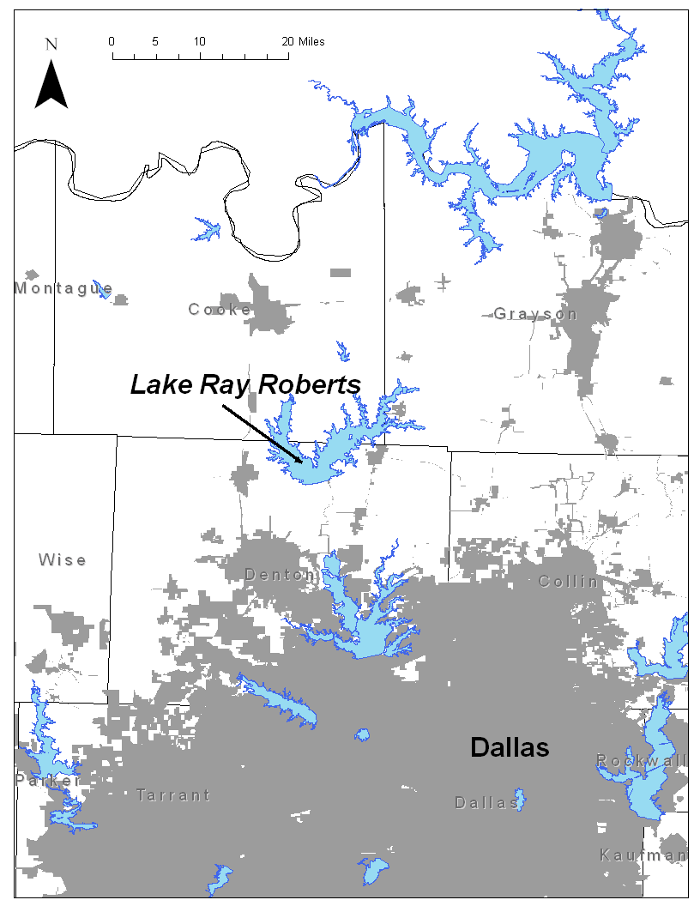

The method for determining reliability in a reservoir in Texas involved simply developing a model of reservoir inflows and outflows, then maximizing the reservoir supply until the capacity almost goes to zero during the drought of record, which is seen in Figures 3 and 8. The Texas Commission on Environmental Quality, TCEQ, maintains surface water accounting models, called Water Availability Models or WAMs, which run this simulation to develop a reservoir’s firm yield, a number that is then used to allocate water rights to various entities.

Using the WAM for the Trinity River Basin, a spreadsheet model of Lake Ray Roberts was developed, using the WAM information for reservoir inflows and net evaporation (TCEQ, 2010). The Ray Roberts storage-elevation-capacity information used came from the Texas Water Development Board database (TWDB, 2010). Maximizing the available supply from the reservoir using this model indicated that the firm yield was just over 90,000 acre-ft/ yr. Figure 9 shows the reservoir storage capacity for the period of record during the simulation.

Figure 8. Lake Ray Roberts Performance During the Period of Record

90,000 acre-ft/yr Firm Yield

# Regression

In order to extend the reservoir simulation to capture the information provided by the drought reconstruction a linear regression was performed using the Cook PDI dataset with both the inflows and net evaporation datasets (from the period of record) used in the WAM. Figure 9 and 10 show the regressions of inflow and net evaporation.

The two regressions’ R-squared values were low, suggesting that the correlation between the two variables during the period of record could be improved. Something to consider is that the tree ring width data that Cook et al. used to construct the PDI could be used directly to perform the linear regressions with the reservoir inflow and net evaporation.

Figure 9. Linear Regression of Inflow

Figure 10. Linear Regression of Net Evaporation

# Results

Once the two input variables for the reservoir model were extended, the model used to determine the firm yield during the period of record was run again, this time with the 1005 years of data. The available water supply was maximized for the 1005 year period until the storage capacity just about dropped to zero. The firm yield using the 1005 year record came to be 78,500 acre-ft/yr. Table 2 compares the two model runs and Figure 11 shows the performance of Lake Ray Roberts during the simulation:

Table 2. Model Runs and Firm Yields

|  |  |
| --- | --- |
| Model Run | Firm Yield |
| Period of Record | 90,000 |
| Extended Drought Record (1005 years) | 78,500 |

Figure 11. Lake Ray Roberts Performance, 1005 Year Reconstructed Period

# Conclusions

By looking at the droughts that are apparent in the 1005 year PDI data set (see Appendix B), it was expected that the huge droughts of the 1050 – 1300 year period would diminish the firm yields of a lake. How much was uncertain, however, and the modeling showing that the lake yield would be reduced by around 13% was interesting in that the reservoir seems to be fairly resilient to enormous potential droughts. A reduction of reservoir allocation of 13% is a significant reduction to municipal water suppliers, who would have to source this water elsewhere, whether it be future reservoirs, or tapping over-extended groundwater sources.

Further research that could be useful would be to use the mathematical description developed above and formulate a stochastic model, generating random future drought events and getting probabilities of failure for reservoirs. Further analysis could include the comparison of reservoir performance with the most recent drought in memory (2007-2008) and why that drought caused such a scare for water suppliers in Texas.

In future work a rigorous look at the errors this data generate could be done, and could be used to perform more sophisticated risk analysis for water suppliers, so that better decisions about investments and pricing structures could be developed.

# References

Cook, E. R., D. M. Meko, D. W. Stahle, and M. K. Cleaveland (1999), Drought reconstructions for the continental United States, J. Clim., 12, 1145–1162. Data developed by Cook, et al was downloaded from <http://www.ncdc.noaa.gov/>

Mathworks, (2010), MATLAB Documentation for Statistics Toolbox: Gamma Distribution. Accessed at <http://www.mathworks.com/access/helpdesk/help/toolbox/stats/brn2ivz-39.html>

Shiau, J.T. (2003), Return period of bivariate distributed extreme hydrological events. Stochastic Environmental Research and Risk Assessment, 17, 42-57.

Texas Commission on Environmental Quality, TCEQ (2010), <http://www.tceq.state.tx.us/permitting/water_supply/water_rights/wam.html>

Texas Water Development Board, TWDB (2010), <http://www.twdb.state.tx.us/data/surfacewater/surfacewater_toc.asp> (see link for “Comprehensive Surface Water Information.”)

Appendix A. Code for Extraction of Drought Events

Sub Find_droughts()

is_drought = False

numrecon = 1008

j = 0

ReconTally = 0

PrintMe = False

yearTally = 0

interarrival = 0

Dim recon As Range

Set recon = Worksheets("recon").Range("B3:B1010")

For i = 1 To numrecon

If recon(i) < 0 And Not is_drought Then

is_drought = True

j = j + 1

ReconTally = recon(i)

yearTally = 1

interarrivalTime = i - interarrival

interarrival = i

ElseIf recon(i) < 0 And is_drought Then

ReconTally = ReconTally + recon(i)

yearTally = yearTally + 1

ElseIf recon(i) >= 0 And is_drought Then

is_drought = False

DroughtArray(j) = ReconTally

yearArray(j) = yearTally

ReconTally = 0

PrintMe = True

End If

If PrintMe Then

Cells(j + 1, 4) = DroughtArray(j)

Cells(j + 1, 5) = yearArray(j)

Cells(j + 1, 6) = interarrivalTime

PrintMe = False

End If

Next i

End Sub

Appendix B. List of Drought Events

|  |  |  |  |  |
| --- | --- | --- | --- | --- |
| **Start Year** | **End Year** | **Severity** | **Duration** | **Interarrival Time** |
| 998 | 1000 | -7.545 | 3 | 2 |
| 1003 | 1016 | -28.51 | 14 | 5 |
| 1020 | 1025 | -8.395 | 6 | 17 |
| 1028 | 1029 | -1.914 | 2 | 8 |
| 1032 | 1036 | -5.376 | 5 | 4 |
| 1038 | 1045 | -15.449 | 8 | 6 |
| 1047 | 1051 | -7.414 | 5 | 9 |
| 1057 | 1057 | -0.74 | 1 | 10 |
| 1061 | 1063 | -9.135 | 3 | 4 |
| 1066 | 1066 | -0.132 | 1 | 5 |
| 1069 | 1082 | -25.859 | 14 | 3 |
| 1085 | 1086 | -4.481 | 2 | 16 |
| 1089 | 1092 | -6.792 | 4 | 4 |
| 1099 | 1101 | -4.94 | 3 | 10 |
| 1103 | 1104 | -6.003 | 2 | 4 |
| 1107 | 1112 | -12.244 | 6 | 4 |
| 1115 | 1119 | -9.001 | 5 | 8 |
| 1121 | 1134 | -36.018 | 14 | 6 |
| 1137 | 1146 | -16.383 | 10 | 16 |
| 1148 | 1164 | -34.043 | 17 | 11 |
| 1167 | 1167 | -0.755 | 1 | 19 |
| 1181 | 1181 | -0.676 | 1 | 14 |
| 1183 | 1187 | -7.652 | 5 | 2 |
| 1192 | 1195 | -4.546 | 4 | 9 |
| 1198 | 1204 | -16.47 | 7 | 6 |
| 1207 | 1217 | -27.78 | 11 | 9 |
| 1221 | 1226 | -13.637 | 6 | 14 |
| 1229 | 1234 | -17.312 | 6 | 8 |
| 1236 | 1242 | -19.757 | 7 | 7 |
| 1244 | 1251 | -12.442 | 8 | 8 |
| 1254 | 1256 | -10.241 | 3 | 10 |
| 1258 | 1258 | -0.753 | 1 | 4 |
| 1260 | 1261 | -1.322 | 2 | 2 |
| 1269 | 1270 | -3.234 | 2 | 9 |
| 1272 | 1272 | -0.192 | 1 | 3 |
| 1274 | 1277 | -8.634 | 4 | 2 |
| 1279 | 1279 | -1.725 | 1 | 5 |
| 1281 | 1281 | -0.686 | 1 | 2 |
| 1283 | 1283 | -1.583 | 1 | 2 |
| 1287 | 1289 | -4.709 | 3 | 4 |
| 1291 | 1294 | -11.071 | 4 | 4 |
| 1296 | 1297 | -3.64 | 2 | 5 |
| 1299 | 1303 | -7.254 | 5 | 3 |
| 1305 | 1308 | -8.884 | 4 | 6 |
| 1310 | 1310 | -1.564 | 1 | 5 |
| 1315 | 1317 | -8.111 | 3 | 5 |
| 1319 | 1320 | -4.061 | 2 | 4 |
| 1322 | 1322 | -1.32 | 1 | 3 |
| 1325 | 1325 | -0.138 | 1 | 3 |
| 1327 | 1329 | -2.992 | 3 | 2 |
| 1336 | 1336 | -1.866 | 1 | 9 |
| 1345 | 1347 | -7.128 | 3 | 9 |
| 1349 | 1355 | -10.96 | 7 | 4 |
| 1358 | 1358 | -2.315 | 1 | 9 |
| 1360 | 1361 | -4.808 | 2 | 2 |
| 1364 | 1367 | -8.413 | 4 | 4 |
| 1369 | 1372 | -11.102 | 4 | 5 |
| 1374 | 1376 | -6.322 | 3 | 5 |
| 1378 | 1379 | -1.187 | 2 | 4 |
| 1381 | 1384 | -6.801 | 4 | 3 |
| 1386 | 1387 | -5.956 | 2 | 5 |
| 1390 | 1390 | -1.003 | 1 | 4 |
| 1392 | 1393 | -1.549 | 2 | 2 |
| 1397 | 1397 | -1.018 | 1 | 5 |
| 1400 | 1402 | -2.246 | 3 | 3 |
| 1404 | 1405 | -1.6 | 2 | 4 |
| 1410 | 1412 | -6.477 | 3 | 6 |
| 1415 | 1415 | -2.296 | 1 | 5 |
| 1418 | 1419 | -1.544 | 2 | 3 |
| 1421 | 1422 | -7.187 | 2 | 3 |
| 1424 | 1425 | -3.948 | 2 | 3 |
| 1427 | 1427 | -2.522 | 1 | 3 |
| 1430 | 1431 | -2.897 | 2 | 3 |
| 1433 | 1433 | -0.371 | 1 | 3 |
| 1436 | 1437 | -4.04 | 2 | 3 |
| 1440 | 1440 | -0.886 | 1 | 4 |
| 1442 | 1442 | -0.324 | 1 | 2 |
| 1444 | 1447 | -11.141 | 4 | 2 |
| 1450 | 1451 | -4.321 | 2 | 6 |
| 1453 | 1463 | -29.377 | 11 | 3 |
| 1468 | 1473 | -11.721 | 6 | 15 |
| 1481 | 1481 | -2.089 | 1 | 13 |
| 1483 | 1483 | -0.007 | 1 | 2 |
| 1488 | 1490 | -3.663 | 3 | 5 |
| 1492 | 1492 | -0.009 | 1 | 4 |
| 1496 | 1497 | -8.786 | 2 | 4 |
| 1501 | 1507 | -12.855 | 7 | 5 |
| 1510 | 1512 | -6.793 | 3 | 9 |
| 1514 | 1516 | -1.221 | 3 | 4 |
| 1518 | 1518 | -0.785 | 1 | 4 |
| 1521 | 1521 | -0.42 | 1 | 3 |
| 1524 | 1525 | -5.721 | 2 | 3 |
| 1527 | 1530 | -7.438 | 4 | 3 |
| 1532 | 1533 | -3.969 | 2 | 5 |
| 1535 | 1535 | -1.773 | 1 | 3 |
| 1542 | 1544 | -8.839 | 3 | 7 |
| 1547 | 1547 | -0.375 | 1 | 5 |
| 1555 | 1556 | -1.752 | 2 | 8 |
| 1560 | 1561 | -4.619 | 2 | 5 |
| 1563 | 1563 | -0.561 | 1 | 3 |
| 1566 | 1574 | -15.485 | 9 | 3 |
| 1577 | 1577 | -3.207 | 1 | 11 |
| 1581 | 1582 | -1.424 | 2 | 4 |
| 1585 | 1585 | -0.36 | 1 | 4 |
| 1590 | 1592 | -2.697 | 3 | 5 |
| 1595 | 1595 | -1.684 | 1 | 5 |
| 1597 | 1601 | -9.741 | 5 | 2 |
| 1608 | 1608 | -3.556 | 1 | 11 |
| 1616 | 1616 | -0.612 | 1 | 8 |
| 1618 | 1619 | -3.09 | 2 | 2 |
| 1623 | 1623 | -1.859 | 1 | 5 |
| 1625 | 1627 | -8.805 | 3 | 2 |
| 1630 | 1632 | -6.251 | 3 | 5 |
| 1638 | 1638 | -1.426 | 1 | 8 |
| 1641 | 1648 | -14.694 | 8 | 3 |
| 1652 | 1652 | -0.919 | 1 | 11 |
| 1654 | 1654 | -4.089 | 1 | 2 |
| 1656 | 1656 | -0.743 | 1 | 2 |
| 1658 | 1659 | -2.186 | 2 | 2 |
| 1661 | 1661 | -0.312 | 1 | 3 |
| 1664 | 1664 | -1.623 | 1 | 3 |
| 1666 | 1666 | -0.629 | 1 | 2 |
| 1670 | 1670 | -3.613 | 1 | 4 |
| 1673 | 1673 | -0.598 | 1 | 3 |
| 1675 | 1676 | -5.836 | 2 | 2 |
| 1681 | 1682 | -5.76 | 2 | 6 |
| 1684 | 1685 | -4.578 | 2 | 3 |
| 1687 | 1691 | -5.608 | 5 | 3 |
| 1693 | 1693 | -0.146 | 1 | 6 |
| 1696 | 1699 | -7.019 | 4 | 3 |
| 1703 | 1705 | -7.836 | 3 | 7 |
| 1708 | 1710 | -3.594 | 3 | 5 |
| 1712 | 1712 | -0.427 | 1 | 4 |
| 1714 | 1717 | -7.654 | 4 | 2 |
| 1722 | 1722 | -1.649 | 1 | 8 |
| 1724 | 1725 | -3.326 | 2 | 2 |
| 1727 | 1731 | -11.206 | 5 | 3 |
| 1734 | 1734 | -0.376 | 1 | 7 |
| 1736 | 1738 | -6.569 | 3 | 2 |
| 1741 | 1743 | -3.869 | 3 | 5 |
| 1750 | 1757 | -14.353 | 8 | 9 |
| 1763 | 1769 | -6.87 | 7 | 13 |
| 1772 | 1778 | -14.531 | 7 | 9 |
| 1780 | 1780 | -1.657 | 1 | 8 |
| 1785 | 1786 | -7 | 2 | 5 |
| 1789 | 1791 | -8.659 | 3 | 4 |
| 1798 | 1798 | -0.804 | 1 | 9 |
| 1800 | 1801 | -4.476 | 2 | 2 |
| 1805 | 1806 | -6.619 | 2 | 5 |
| 1808 | 1808 | -1.911 | 1 | 3 |
| 1812 | 1812 | -0.9 | 1 | 4 |
| 1816 | 1816 | -0.373 | 1 | 4 |
| 1819 | 1820 | -3.367 | 2 | 3 |
| 1822 | 1822 | -3.258 | 1 | 3 |
| 1824 | 1824 | -3.95 | 1 | 2 |
| 1829 | 1832 | -5.176 | 4 | 5 |
| 1835 | 1835 | -1.535 | 1 | 6 |
| 1837 | 1839 | -2.818 | 3 | 2 |
| 1841 | 1842 | -6.662 | 2 | 4 |
| 1845 | 1848 | -4.245 | 4 | 4 |
| 1852 | 1852 | -0.441 | 1 | 7 |
| 1854 | 1857 | -10.877 | 4 | 2 |
| 1859 | 1864 | -17.239 | 6 | 5 |
| 1874 | 1874 | -2.265 | 1 | 15 |
| 1879 | 1880 | -2.853 | 2 | 5 |
| 1886 | 1887 | -7.578 | 2 | 7 |
| 1889 | 1889 | -0.9 | 1 | 3 |
| 1893 | 1897 | -7.837 | 5 | 4 |
| 1899 | 1899 | -0.285 | 1 | 6 |
| 1901 | 1902 | -5.042 | 2 | 2 |
| 1904 | 1904 | -1.646 | 1 | 3 |
| 1906 | 1906 | -0.518 | 1 | 2 |
| 1909 | 1911 | -4.416 | 3 | 3 |
| 1913 | 1913 | -1.569 | 1 | 4 |
| 1916 | 1918 | -7.919 | 3 | 3 |
| 1925 | 1925 | -6.444 | 1 | 9 |
| 1931 | 1931 | -0.209 | 1 | 6 |
| 1934 | 1934 | -2.673 | 1 | 3 |
| 1936 | 1940 | -6.475 | 5 | 2 |
| 1943 | 1943 | -0.102 | 1 | 7 |
| 1948 | 1948 | -0.246 | 1 | 5 |
| 1951 | 1956 | -18.978 | 6 | 3 |
| 1959 | 1959 | -0.417 | 1 | 8 |
| 1961 | 1961 | -0.363 | 1 | 2 |
| 1963 | 1964 | -4.609 | 2 | 2 |
| 1966 | 1967 | -3.354 | 2 | 3 |
| 1971 | 1972 | -5.399 | 2 | 5 |
| 1974 | 1974 | -0.342 | 1 | 3 |
| 1978 | 1978 | -2.435 | 1 | 4 |
| 1980 | 1980 | -1.617 | 1 | 2 |
| 1984 | 1984 | -2.062 | 1 | 4 |
| 1988 | 1988 | -1.306 | 1 | 4 |
| 1996 | 1996 | -1.619 | 1 | 8 |
| 1998 | 2000 | -4.101 | 3 | 2 |
| 2003 | 2003 | -0.726 | 1 | 5 |